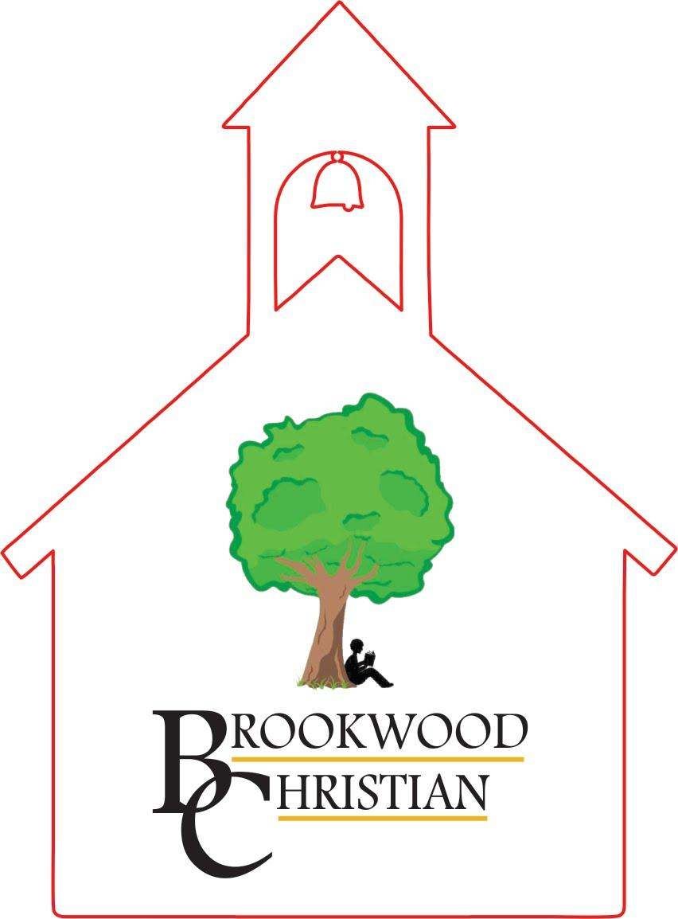

            - Parent and Student Handbook
Updated 2/1/23

GAC accredited
SB10/GSNS Approved

1st through 12th grade classes
Specializing in Dyslexia
4728 Wood Street
Acworth, GA 30101
On the northern edge of Historic Downtown Acworth

Phone: 678-401-5855
Email: Office@BrookwoodChristian.com
Website: www.BrookwoodChristian.com

Mission Statement
Our Mission is to encourage exceptional students in grades 1 through 12 to work to their very best abilities in a relaxed, low stress Christian environment. Individual learning styles are nurtured and strengths are developed while specific deficits are remediated. We strive to improve our students’ quality of life through academics, physical, emotional, cultural, social, and spiritual growth.

Students with Dyslexia
Students with specific learning disabilities in reading and math receive appropriate instruction in small classes of 10 or less. Reading and Math are very intensive, structured, and taught with a low teacher to student ratio. Teachers use multi-sensory methods to teach the students. Our various curricula are research tested and highly recommended for students with learning differences. Students learn to read by using the Wilson Reading System. Wilson is based on Orton Gillingham methods and uses a multi-sensory, systematic approach to phonemic instruction, spelling, and reading comprehension. Students learn math through various curricula such as Teaching Textbooks, Drops in the Bucket, Houghton Mifflin, and SRA Spectrum. Science and Social Studies are taught through unit studies in nine-week blocks. This program allows students to integrate knowledge in all subjects as it fosters discovery learning and logic.

Educational Goals and Objectives:

Provide intensive small class instruction (that is appropriate, research based, and high quality) in a safe, nurturing, low stress, learning environment for 1st – 12th grade students who struggle in a regular classroom setting.

Provide an appropriate learning environment for students with language based learning differences that include but are not limited to Dyslexia.
Provide a structured environment that still allows for discovery learning
Provide guidance for social skills, goal setting, self-regulation, coping skills, study skills, etc.
Provide a learning environment that allows movement for students who need to move in order to learn.
Provide parents of dyslexic children with support, resources, and educational opportunities for them and their children.

Curriculum
All students will receive intensive instruction in reading/language arts and math.
*Reading instruction for students who are Dyslexic will be based on the Wilson Reading System and other appropriate reading programs. Reading instruction for students with comprehension difficulties will be based on AGS Pearson Longman books, Visualizing and Verbalizing, and other appropriate programs. All students study novels. Language Arts classes heavily emphasize writing, grammar, and Latin roots, prefixes, and suffixes.
*Math instruction is based on hands on method. Math curriculum includes Teaching Textbooks, Spectrum Math by SRA, Drops in the Bucket by Frog publications, and Houghton Mifflin Math.
*Reading and math groups will be organized by student ability levels.
*Throughout the day as well as through small group time, students will receive spiritual guidance without judgment. Through the thematic units in history and science, students will learn to respect God’s creation: people, animals, and the earth. BCLS is non-denominational and employs teachers from all denominations.
*All courses and curriculum fulfill Georgia’s performance standards. However, most students will not perform on grade level, and may not be able to fulfill the standards for their chronological age or grade level. Our primary purpose is to meet the child’s needs rather than impose a developed structure upon their education.
*The type of diploma a child receives depends on the coursework they are able to complete. Brookwood offers General and College Prep diplomas. We do not offer special education diplomas.

Teachers
All teachers must hold at least a bachelor’s degree or higher and have at least 18 hours credit in their teaching field. Teachers are trained in the curriculum and methods used at Brookwood through workshops or private consultants. Background checks are run on all office staff, teachers, Para pros, and substitutes. Teachers must uphold professional educational ethics at all times. Their primary responsibility is the welfare, dignity, and education of each student. They must also maintain appropriate relationships with others at school and in the community by promoting mutual respect with students, parents, and co-workers.

Student/Parent Policies

Hours of Operation
School is in session from 9:00 a.m. to 3:00 p.m. Staff members will be at the school as early as 7:30 A.M. for drop off. Please make sure students are on time and ready to begin at 9:00. Please be in the carpool line at dismissal time. Parents will be charged $10 for after school care if a child is picked up after 3:15.

Carpool
Please form a line with cars. In order to ensure child safety, please do not pass other cars in line. We ask all children to walk and enter the car on the passenger side. However, children sometimes run from their cars as other cars begin to pull around. If you plan to leave your car unattended, please park in a designated space, turn off the engine, remove the keys and lock all doors. In order to expedite the morning carpool process, please have your children ready for drop off. Please avoid conferring with teachers during drop off and pick up, as they are responsible for student safety at this time. Please send a note to your child’s teacher anytime there is a change in your regular carpool arrangements. We will not release children without proper verification and identification.

Early Pick-Up
When you pick up your child early from school, you must check them out and pick them up from the office.

Inclement Weather
BCLS will not hold school when there is a hazardous situation on the roads. We will follow the Cobb County School closings.

Custody Policy
Copies of custody papers or of guardianship must be on file in the school office if you have a custody agreement regarding your child. Unless we have official documentation on file, the school cannot prevent a parent listed on the birth certificate from picking up a child.

Meals and Snacks
Parents are to provide a nutritional lunch and snacks for their children. Protein snacks are encouraged for students with ADHD.

Homework
Understanding that too much homework can be counterproductive and take away from family time, minimal homework is required. However, if your child is in a college prep high school program, more homework will be required.
Many of our students attend church, take sports classes, belong to clubs, and go to therapy or tutoring appointments after school. These activities are encouraged and make homework difficult.
For students who need homework, it will be assigned based on their individual needs and abilities. Also, when students do not finish their work in class, they will be asked to complete it at home. If it is not completed at home, students must complete the work on Friday before they can participate in the arts activities.

Textbooks, Workbooks, and Supplies
All supplies, computers, and books are property of the school and must be treated with care. Parents will be billed for lost or damaged items. The application fee of $300 goes toward consumable materials and workbooks. It is not refundable.

School Pictures
Please watch for notices and purchase price information regarding photographs of individual children and classroom groups. A local professional photographer will take school pictures in the fall. A basic set of photos will be included with tuition, but parents may order more from the photographer.

Dress Code
Students have daily exercise and should be dressed in comfortable clothing that is appropriate for physical activity: comfortable, safe, and modest. As a general guideline, no skin or underwear should ever be visible between the top of the chest and the mid thighs, even during exercise or play. Students should not wear clothing that has questionable printed material.

Prohibited Items
This is a tobacco and drug free campus. Any medications should be given to the building administrator. Only designated staff members with current licenses may have a firearm on campus. Students should never have a firearm on campus.

Electronics:
During school, electronics are to be kept in a pocket, purse, or book bag. It is preferable that students do not bring them to school at all. Students are not to use or have electronics out during school hours. The teacher will confiscate electronic items that are seen including but not limited to phones.

Grades and Report Cards
Students have periodic evaluations to see if they are grasping the concepts they are being taught. Reports are available on Renweb/FACTS at nine-week intervals during the year. Students will receive percentage grades on their report cards every nine weeks.

Standardized Tests
The Woodcock Johnson test is used to assess reading and math levels each year.

Student Records
A permanent cumulative file is maintained for each student. Files hold health records, progress reports, and standardized test results. We will release copies of the contents of the file to another school upon written request providing that the parent's financial obligations are current. Records will not be released if a parent is behind in payments. Please allow 2 weeks for records to be sent (after all payments are received). After the students have been withdrawn for a 7-year period, all records are destroyed.

Change of Status
Whenever you experience a change in address, home phone, work phone, carpool or enrollment, please notify your child’s teacher immediately in writing.

Computer Policy
Students are not allowed to use personal computers and tablets at school.
Students are not to alter software and settings. Software may not be copied without permission. Games may only be played at designated times, and only those games installed and/or approved by the school staff for student use may be played. The use of the Internet is to be used for educational reference and information only. If the student should see inappropriate language or graphics, it is the student's responsibility to immediately terminate the exposure and report the incident to the teacher. Students who cast to classroom televisions without being told to do so or who change teacher settings are subject to expulsion. Students who repeatedly use computers inappropriately will no longer be allowed to use them and may be expelled.

Field Trips
The school will offer various field trips throughout the year. Parent volunteers provide transportation for these trips. A field trip permission form with the parent’s signature must be returned to the teacher before a student's participation is permitted. Generally, there is a cost to parents for admission. Parents are encouraged to go with their children on field trips.

Fire and Tornado Drills
Fire drills are conducted monthly during the school year. Tornado drills are conducted twice yearly. Students are expected to walk quietly and quickly and to follow the teacher's directions.

Birthdays
You may celebrate your child’s birthday at school by bringing in a special snack (cupcakes, cookies, popcorn, etc.) to be eaten after lunch or at the end of the day.

Checking Out
Adults must be listed on the pick up or carpool form, present identification, and sign out the student. If the adult is not authorized to pick up the student, they will be asked for a photo I.D., which will be photo copied. School personnel will then call the child’s parent or guardian for permission to release the student. If the parent cannot be reached, school personnel will check the file for a custody agreement. If necessary, proper authorities will be notified. A student will not be released to an unauthorized person without parent permission.

Communication
Staff members stay in contact with the use of walkie-talkies and cell phones.

Phone Numbers and Addresses
A student directory is in Renweb/Facts under the parent portal. Parents wishing to not have their phone numbers and addresses published should be sure to click the privacy button. All parents/guardians should keep Renweb/Facts updated with accurate information.

Staff and Teacher Contacts
Staff may be contacted by leaving a phone message, sending email, or by writing a note. Calls and emails will be returned during breaks or after school. Teachers and staff should not be contacted at home unless they have asked to be contacted at home and have personally given you their phone numbers.

Parent/Teacher Resolution Protocol
We encourage parents to share any concern they may have with their child’s teacher. The following guidelines apply.
1st: Parents should share concerns with their child’s teachers. The teacher should then acknowledge the concern and set up a time for a meeting with the parent to discuss possible solutions. The teacher may choose to receive counsel from another teacher or administrator before, during, or after the meeting.
2nd: If a parent follows this protocol and feels a resolution was not reached, he/she may then and only then schedule a meeting to discuss that concern with an administrator.
3rd: Teachers should keep the administration notified of ongoing concerns.
4th: Teachers should keep an ongoing record of parent-teacher interactions.

Conferences
Parent conferences are available upon request. Parents should contact the building administrator (Danielle or Becky) to schedule a conference with more than one teacher. Appointments should be scheduled in advance since discussions are not possible at drop-off and pick-up times.
NDING ORDERS
IMMUNIZATION REQUIREMENTS
Law requires Georgia Immunization Certification 3231. Failure to provide written documentation regarding your child’s immunization history for school records may result in penalties and fines for the school. While it is our desire that every child enters the school year as planned, no child may be admitted to classes without the required documentation. The form required under law is the Department of Human Resources form 3231, 3300, and 3189. Form 3231 is the Certificate of Immunization. Form 3300 Certification of eye, ear and dental examination (dental section to be completed by your dentist). For students entering the sixth grade, Georgia law now requires Form 3189 (an additional dose of MMR vaccine) and the varicella vaccine or proof of immunity. Your child should see his/her pediatrician once a year for a well check-up until age seven, then every 1.5 – 2 years after that.

Attendance and Absence Policy
Children need to attend school daily in order to make steady academic progress, develop friendships and peer relationships, and function smoothly within the class routine. Please try to schedule all outside appointments after school when possible.

Excused Absences:
Planned: doctor appointments, mission trips, and college visits (must be approved in advance).
Unplanned: illness, family illness, bereavement (must send note the day the child returns). Please keep your child home when sick. A Doctor’s note will be required after the 10th absence.
After 10 absences, students may be required to attend summer school to complete classes to receive credit.

Guidelines to Follow:
Children should be without fever (<99.5), vomiting, diarrhea, or runny noses (green or yellow mucus), and must have received treatment for strep and pink eye for 24 hours, and must be free of all mononucleosis symptoms and any nits from lice for 24 hours or more before returning to school. Children who develop these symptoms at school must be picked up from school.
Children may return to school when all bumps from chicken pox are scabbed.

Prescription Medication
Parents must complete and sign a medicine administration form, which will indicate the reason for administration, the medication, possible side effects, and physician to be called in case of reaction, and the dosage. The child is responsible for coming to the teacher for the proper administration of medication.

Medication must be brought to school in the original container labeled by the pharmacy or physician with the student's name, physician's name, date of original prescription, name and strength of medication and directions for taking.

Non-Prescription Medications
Parents must also indicate on the medication form that the child can be given over the counter medications such as Tylenol, Advil, or Benadryl.
Non-prescription medications must be brought to school in their original container.

No child shall possess prescription or non-prescription drugs during the school day. An exception will be made for inhalers, epi-pens, and insulin for diabetics. However, the school must have prior written permission from the child’s parents/legal guardian and the physician.

Emergencies
First Aid treatment will be rendered for minor injuries. Students who become ill during the day should inform their teachers, and the parents will be called.
Should a child become injured (more than minor scrapes and bruises) during the day, parents will be notified.
If parents cannot be reached, or if time is of the essence, school personnel will then call 911 or transport the child to a medical facility. The hospital of preference will be Kennestone unless instructed otherwise by emergency medical workers.
Please provide the school with a copy of your insurance card, so that prompt treatment may be given to your child. Parents are responsible for keeping the school informed of changes in phone numbers and emergency contact information.

Crisis Intervention
In the event of a crisis on campus, a teacher will call for help by walkie-talkie, school phone, or cell phone. Authorities will be summoned. All teachers will be notified to either lock down (lock classroom doors and remain inside until instructed otherwise) or evacuate (exit the building through the closest exit and stay on the playground or in the parking lot).
If we have to evacuate the property, students will be held at the First Baptist Church for parent pickup.
Post Crisis Intervention: If a crisis occurs to one or more students on or off campus, someone from the school will contact parents by emergency text, letter or by phone explaining what has occurred. Parents will be invited to come to school with their children the next morning. Counselors will talk with students and with parents about the event. Counselors will monitor students and be available to students and parents with questions and concerns. DURE FOR

Visitor Safety Plan
Visitors are required to enter through the door by the parking lot. Upon entering, visitors should go to the office, sign in, present identification, and sign out as they leave.

Recommended Reading for Parents
Bellis, Teri James: When the Brain Can’t Hear
Gardner, Howard: The Unschooled Mind, & Frames of Mind
Jensen, Eric: Teaching with the Brain in Mind.
Kranowitz, Carol Stock: The Out of Sync Child.
Levine, Mel, All Kinds of Minds
Shaywitz, Sally: Overcoming Dyslexia.
Tobias, Cynthia. How They Learn.
Wise, Jessie & Bauer, Susan Wise: The Well Trained Mind.

Student Behavior
BCS is not designed to meet the needs of students with behavior disorders. We do not offer behavior modification. We are not trained to meet the needs of autistic children and have not been successful in serving students with autism.

General rules of conduct are as follows:
- Students are to be respectful to teachers by listening, following directions, and displaying a positive attitude. “Talking back” to an adult is not permitted.
- Students are to be respectful to other students by listening when another student is sharing in class, encouraging others and avoiding negative comments. Teasing of other students and/or calling names are not acceptable.
- Students cannot take or damage other people’s or the school’s property.
- Students will not be allowed to disrupt the learning environment for other students. Repeated violations will result in expulsion.
- Hitting, kicking, pushing, and other forms of physical violence and aggression will result in expulsion.
- Threatening violence, openly condoning violence, obsessing over weapons and/or violent acts will result in expulsion.

Depending on the situation, temporary or permanent removal from the school may be required.
If a child is expelled, parents will still be responsible for the full tuition.

Discipline
Logical and natural consequences will be used. We do not use behavior modification programs and are not qualified to work with students with emotional behavioral disorders.
If a student's behavior continues to be disruptive, the student will be put on a probation period. After 30 days, the school administration will meet with the parents to determine if the student may continue at the school.

Extremely disruptive behavior, threats of violence, obsessive talk of violence, or behavior that causes injury to self or others may be cause for immediate expulsion from the school, without a probationary period.

Financial Information for 23/24:

Tuition:
21,000 Tuition: Includes consumable supplies, before school care, yearbook, basic school picture package, 1 field trip, and art supplies.

Deposit: $300 deposit is Non-refundable, but does go toward the total

Payment Plans: 1st Payment Due:
1 Pay plan August 1
10 Pay Plan August 1
12 Pay Plan June 1

Scholarships or discounts may be available to enrolled students in good financial and academic standing. The scholarship committee will also take into consideration the financial need of scholarship applicants. You must apply each year through FACTS.
You may also apply for a low interest education loan through Sallie Mae. Our school ID for Sallie Mae is 607135.

For information on state provided scholarships, go to www.doe.k12.ga.us.
- Under “Special Programs” click on “Georgia Special Needs Scholarship.” Click on “Calculate” under “Estimate Your Scholarship Award.” Print out your estimated amount. Fill out the “Parent Intent Form.”
- Under “Special Programs” click on “Tax Credit Program.” This allows a tax credit for a donation to a private school. This donation goes toward tuition for students transferring from public schools.

ADMISSION PROCEDURES
Brookwood Christian School’s admission procedures ensure that each student is appropriate for one of our programs. Appropriate students will either have a true mild to moderate language based learning disability such as dyslexia. Our focus is academic not emotional or behavioral. Students who are not performing well in school due to emotional or behavior problems will not be successful with our program and we will not allow them to stay. If you feel this is an appropriate school for your child, the following admission procedures should be followed.

- Schedule a personal tour of our school.
- Schedule a shadow day for your child. We will let you know by the end of the day if we think your child is a good fit for our program.
- Submit the application along with a $300 non-refundable deposit and the most current psychological report. If you do not have a current psychological report, please present documentation such as standardized test reports, report cards, SST files, etc.
- Give your child's current school the release form requesting his/her transcript, medical records, and test scores be mailed to us.
- Once all of these items have been received, a decision will be made. Decisions made by the Admissions Committee are based upon all information submitted, testing results, space availability and appropriateness of the child's learning disability.

Please watch notices on re-enrollment deadlines. Following the re-enrollment deadline, enrollment will be available to outside accepted applicants. After vacancies are filled, all other interested students will be placed on a wait list. Current students who do not re-enroll by the deadline will also be placed on a wait list.

Nondiscriminatory Policy
BCLS admits students of any race, color, national and ethnic origin to all the rights, privileges, programs, and activities generally accorded or made available to students at the school. It does not discriminate on the basis of race, color, national and ethnic origin in administration of its educational policies, admissions policies, scholarship and loan programs, and athletic or other school-administered programs.

Please send in any other needed meds. Meds should be in original containers and inside a clear baggy with your child’s name on it.
I request that school staff administer or assist my child in taking medications. I release and hold harmless the board, the school, its agents, and any school employee from a liability for administering any authorized medication.
Parent’s or Legal Guardian’s Signature:_____________________________________

PARENTAL AGREEMENT FORM
*I agree to treat all students and staff members of Brookwood Christian School with respect and cooperation and abide by the policies of Brookwood Christian School outlined in the handbook and other publications.
*I will see that my child has good attendance. I will see that he/she arrives on time and is picked up on time. I understand there is a $10 fee for picking up my child after 3:30, and my child will go into after school care for that day.
*I will volunteer at least 2 hours per year. This time does not have to be during the school day, but can be at home or during a Saturday event.
*I will read to my child at least 15 minutes per day and/or have my child read to me at least 15 minutes per day (either way, the child should have contact with books for a total of 30 minutes per day at home).
*I agree to allow my child to go on walks with a teacher around the school and into downtown, the library, farmers market, or lake area at any time during the regular school day.
*I agree to release Brookwood Christian School from any responsibility for property damage, illness, accidents, or injury incurred by my child at this school or on school related activities - not due to negligence on the part of the staff or other personnel.
*I agree to allow my child to participate in all school related activities, field trips, physical education activities, etc. I understand that parents and teachers will provide transportation for school activities in their privately owned vehicles. I absolve and release the school, its officers, trustees, staff, faculty, employees, and volunteer drivers from liability to my child or to me or any other parent or guardian of the child because of injury sustained at school during any school activity or during travel to and from any school activity.
*I agree to allow Brookwood Christian School, at my expense, to institute emergency treatment through my family physician or any other recognized medical resource such as but not limited to an ambulance. When possible, the school will contact me prior to such action.
*I agree to allow Brookwood Christian School to take photos and video of my child for the newspaper or any other school promotions or advertisements and for my contact information to be placed in the directory.

Date:__________Student’s Name:____________________________________________
Parents’ or Guardians’ Signatures:____________________________________________
Parents can be assured that the staff will treat parents and students with respect and cooperation, operate in a professional manner, and make every possible effort to assure safety and a quality education for your child.
Records Release Authorization

Student’s Name:_____________________________Grade:_________
Parent’s or Guardian’s Name:__________________________________
School Name:_____________________________________________
Homeroom Teacher:________________________________________
Date:___________________

Please forward the following items to Brookwood Christian School, 4728 Wood Street, Acworth, GA 30101. Thank you.

Most recent report card
All Transcripts or Records
All Standardized Test Reports
All Psychological/Educational testing Reports
All Special Education Records including evaluation results
Current IEP
All Health Records (vision screening, immunization, birth cert., etc.)
All Disciplinary Reports

Parent or Guardian Signature:________________________________________________
Date:___________________

